**ME (Embedded Systems)**

**ESD 5153 – MICROCONTROLLER AND ITS APPLICATIONS**

**Assignment 2**

Name: VARSHA V D

Reg No: 221039016

1. Check whether a received string from the UART0 is a palindrome or not. Display the same

on the LCD.

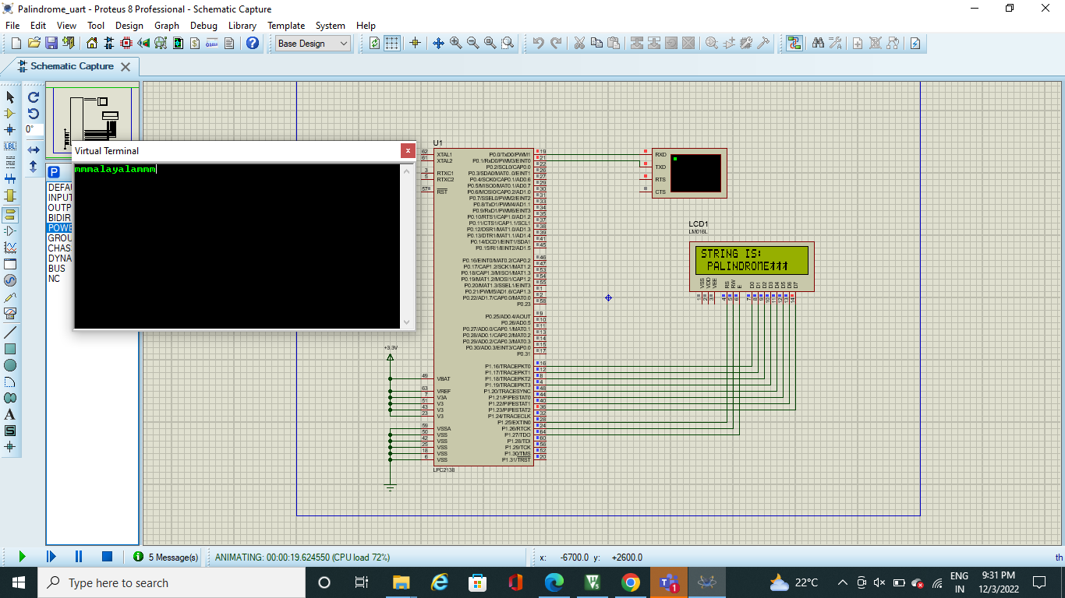

2. Using TIMER of LPC21xx, on reading a ‘0’ on the SW, generate a square wave of delay 1 sec

and on ‘1’ generate the delay of ½ sec.

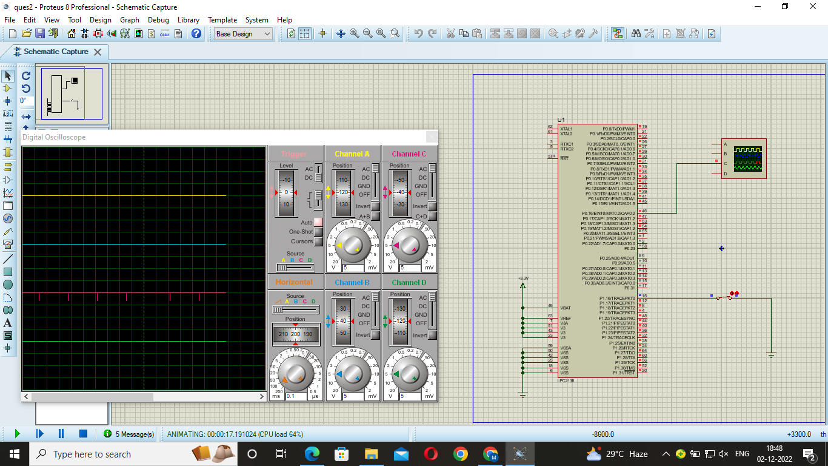

3. Receive a 3 digit number from UART and check whether it is an ARMSTRONG number or

not. Display back on the result on UART.

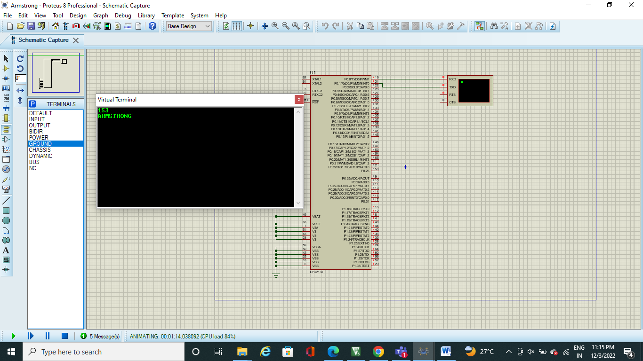

4. Generate a sine wave using DAC.

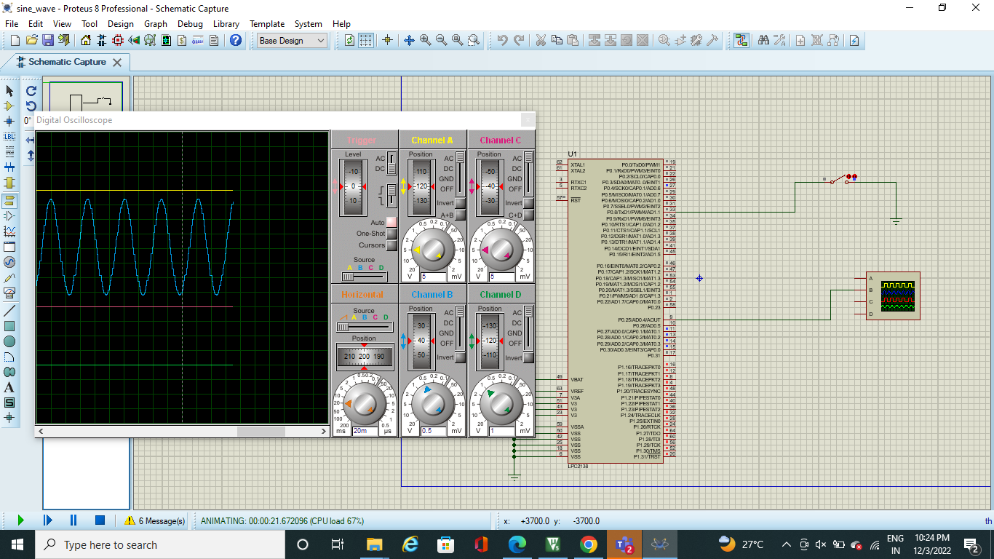

5. Connect a potentiometer to P0.28(AD0.1) and display the voltage value on the LCD.

